# Design of Reconfigurable MIMO Antenna with Enhanced Performance for 5G Application

Aritra Das (University Roll: - 12200319056)

Subhodeep Karmakar (University Roll: - 12200319039)

Chandrayee Dutta Chowdhury (University Roll: - 12200319049)

Subhrajit Nandy (University Roll: - 12200320062)

Under the guidance of

Dr. Juin Acharjee

Assistant Professor

Department of ECE

Submitted in partial fulfillment of the requirement of the Degree of Bachelor of Technology

of Maulana Abul Kalam Azad University (formerly West Bengal University of Technology). Kolkata

Department of Electronics and Communication Engineering

# St. Thomas’ College of Engineering and Technology

4 D.H. Road, Kolkata 700023

May, 2023

## Vision of the Department

## To build a strong teaching and research environment to cater to the manpower needs in Industrial and Academic domains of the rapidly growing Electronics and Communication Engineering.

## Mission of the Department

* **To produce certified industry-ready professional in Electronics and Communication Engineering, though innovative educational programs incorporating laboratory practices and project-based teaching-learning processes, in a modern environment.**
* **To create knowledge base of advanced technologies through research in the area of Electronics and Communication, for competitive and sustainable development of the country.**
* **To groom the department as a learning center to inculcate advancement of technology in Electronics and Communication Engineering with social values and environmental awareness.**

## Program Specific Outcome (PSOs)

After completion of program graduate engineer would have:

* **PSO1. Professional skills: An ability to apply the knowledge in Electronics and Communication Engineering in various areas, like Communications, Signal processing, VLSI and Embedded Systems.**
* **PSO2. Competency: An ability to qualify at the State, National and International level competitive examinations for employment, higher studies and research**

### **Program Outcome**

***Engineering Graduates will be able to:***

1. **Engineering knowledge**: Apply the knowledge of mathematics, science, engineering fundamentals, and an engineering specialization to the solution of complex engineering problems.
2. **Problem analysis**: Identify, formulate, review research literature, and analyze complex engineering problems reaching substantiated conclusions using first principles of mathematics, natural sciences, and engineering sciences.
3. **Design/development of solutions**: Design solutions for complex engineering problems and design system components or processes that meet the specified needs with appropriate consideration for the public health and safety, and the cultural, societal, and environmental considerations.
4. **Conduct investigations of complex problems**: Use research-based knowledge and research methods including design of experiments, analysis and interpretation of data, and synthesis of the information to provide valid conclusions.
5. **Modern tool usage**: Create, select, and apply appropriate techniques, resources, and modern engineering and IT tools including prediction and modeling to complex engineering activities with an understanding of the limitations.
6. **The engineer and society**: Apply reasoning informed by the contextual knowledge to assess societal, health, safety, legal and cultural issues and the consequent responsibilities relevant to the professional engineering practice.
7. **Environment and sustainability**: Understand the impact of the professional engineering solutions in societal and environmental contexts, and demonstrate the knowledge of, and need for sustainable development.
8. **Ethics**: Apply ethical principles and commit to professional ethics and responsibilities and norms of the engineering practice.
9. **Individual and teamwork**: Function effectively as an individual, and as a member or leader in diverse teams, and in multidisciplinary settings.
10. **Communication**: Communicate effectively on complex engineering activities with the engineering community and with society at large, such as, being able to comprehend and write effective reports and design documentation, make effective presentations, and give and receive clear instructions.
11. **Project management and finance**: Demonstrate knowledge and understanding of the engineering and management principles and apply these to one’s own work, as a member and leader in a team, to manage projects and in multidisciplinary environments.
12. **Life-long learning**: Recognize the need for, and have the preparation and ability to engage in independent and life-long learning in the broadest context of technological change.

#### **Course Outcomes for Final Year Project**

***After completion of the project, student will be able to:***

|  |  |  |
| --- | --- | --- |
| **CO**  **no.** | **Outcome Statements** | **Bloom’s Level** |
| CO1 | Apply technical knowledge in the solution of complex real-life problems related to public health and safety, culture, society, and environment | 3 |
| CO2 | Review research literature and use the research-based knowledge to identify, formulate, and analyze the problem | 5 |
| CO3 | Design innovative solutions for complex engineering problems, which will be published as research paper or developed as a marketable product in future | 6 |
| CO4 | Apply modern tools to design and develop the solution to problem | 3 |
| CO5 | Assess societal, health, safety, legal and cultural issues relevant to project and the responsibilities relevant to the professional engineering practice. | 5 |
| CO6 | Evaluate the impact on the environment of working project | 5 |
| CO7 | Apply ethical principles and commit to ethics and responsibilities related to engineering practice. | 3 |
| CO8 | Function effectively as a member or leader of a team | 3 |
| CO9 | Communicate effectively on professional activities with the team members, superiors and with society at large | 3 |
| C10 | Plan, manage the project and control finance as a member and leader in a team. | 3 |
| C11 | Apply the knowledge acquired during the project, in future higher studies or professional job. | 4 |

Bloom’s Level: Remember = 1, Understand = 2, Apply =3 Analyze = 4 Evaluate = 5, Create = 6

#### **Program Outcomes -Competencies – Performance Indicators (PIs)**

|  |  |
| --- | --- |
| **PO 1: Engineering knowledge:** Apply the knowledge of mathematics, science, engineering  fundamentals, and an engineering specialization for the solution of complex engineering problems. | |
| **Competency** | **Indicators** |
| **1.1** Demonstrate competence in mathematical modelling | * + 1. Apply mathematical techniques such as calculus, linear algebra, and statistics to solve problems     2. Apply advanced mathematical techniques to model and solve Electronics engineering problems |
| 1.2 Demonstrate competence in basic  sciences | 1.2.1 Apply laws of natural science to an engineering problem |
| 1.3 Demonstrate competence in engineering fundamentals | 1.3.1 Apply fundamental engineering concepts to solve engineering problems |
| 1.4 Demonstrate competence in specialized engineering knowledge to  the program | 1.4.1 Apply Electronics engineering concepts to solve engineering problems. |

|  |  |
| --- | --- |
| **PO 2: Problem analysis: Identify, formulate, research literature, and analyze complex engineering problems reaching substantiated conclusions using first principles of mathematics, natural sciences, and engineering sciences.** | |
| **Competency** | **Indicators** |
| 2.1 Demonstrate an ability to identify and formulate complex engineering problem | * + 1. Articulate problem statements and identify objectives     2. Identify engineering systems, variables, and parameters to solve the problems     3. Identify the mathematical, engineering and other relevant knowledge that applies to a given problem |
| 2.2 Demonstrate an ability to formulate a solution plan and methodology for an engineering problem | * + 1. Reframe complex problems into interconnected sub-problems     2. Identify, assemble and evaluate information and resources.     3. Identify existing processes/solution methods for solving the problem, including forming justified approximations and assumptions     4. Compare and contrast alternative solution processes to select the best process. |
| 2.3 Demonstrate an ability to formulate and interpret a model | * + 1. Combine scientific principles and engineering concepts to formulate model/s (mathematical or otherwise) of a system or process that is appropriate in terms of applicability and required accuracy.     2. Identify assumptions (mathematical and physical) necessary to allow modelling of a system at the level of accuracy required |
| 2.4 Demonstrate an ability to execute a solution process and analyze results | 2.4.1 Apply engineering mathematics and computations to solve mathematical models 2.4.2 Produce and validate results through skillful use of contemporary engineering tools and models   * + 1. Identify sources of error in the solution process, and limitations of the solution.     2. Extract desired understanding and conclusions consistent with objectives and limitations of the analysis |

|  |  |
| --- | --- |
| **PO 3: Design/Development of Solutions: Design solutions for complex engineering problems and design system components or processes that meet the specified needs with appropriate consideration for public health and safety, and cultural, societal, and environmental considerations. .** | |
| **Competency** | **Indicators** |
| 3.1 Demonstrate an ability to define a complex/ open-ended problem in engineering terms | * + 1. Recognize that need analysis is key to good problem definition     2. Elicit and document, engineering requirements from stakeholders     3. Synthesize engineering requirements from a review of the state-of-the-art     4. Extract engineering requirements from relevant engineering Codes and Standards such as ASME, ASTM, BIS, ISO and ASHRAE.     5. Explore and synthesize engineering requirements considering health, safety risks, environmental, cultural and societal issues     6. Determine design objectives, functional requirements and arrive at specifications |
| 3.2 Demonstrate an ability to generate a diverse set of alternative design solutions | * + 1. Apply formal idea generation tools to develop multiple engineering design solutions     2. Build models/prototypes to develop a diverse set of design solutions     3. Identify suitable criteria for the evaluation of alternate design solutions. |
| 3.3 Demonstrate an ability to select an optimal design scheme for further development | * + 1. Apply formal decision-making tools to select optimal engineering design solutions for further development     2. Consult with domain experts and stakeholders to select candidate engineering design solution for further development |
| 3.4 Demonstrate an ability to advance an engineering design to defined end state | * + 1. Refine a conceptual design into a detailed design within the existing constraints (of the resources)     2. Generate information through appropriate tests to improve or revise the design |

|  |  |  |  |
| --- | --- | --- | --- |
| **PO 4: Conduct investigations of complex problems: Use research-based knowledge and research methods including design of experiments, analysis and interpretation of data, and synthesis of the information to provide valid conclusions.** | | | |
| **Competency** | | **Indicators** | |
| 4.1 Demonstrate an ability to conduct investigations of technical issues consistent with their level of knowledge and understanding | | * + 1. Define a problem, its scope and importance for purposes of investigation     2. Examine the relevant methods, tools and techniques of experiment design, system calibration, data acquisition, analysis and presentation     3. Apply appropriate instrumentation and/or software tools to make measurements of physical quantities     4. Establish a relationship between measured data and underlying physical principles | |
| 4.2 Demonstrate an ability to design experiments to solve open-ended problems | | * + 1. Design and develop an experimental approach, specify appropriate equipment and procedures     2. Understand the importance of the statistical design of experiments and choose an appropriate experimental design plan based on the study objectives | |
| 4.3 Demonstrate an ability to  analyze data and reach a valid conclusion | | * + 1. Use appropriate procedures, tools and techniques to conduct experiments and collect data     2. Analyze data for trends and correlations, stating possible errors and limitations     3. Represent data (in tabular and/or graphical forms) so as to facilitate analysis and explanation of the data, and drawing of conclusions     4. Synthesize information and knowledge about the problem from the raw data to reach appropriate conclusions | |
| **PO 5: Modern tool usage: Create, select, and apply appropriate techniques, resources, and modern engineering and IT tools including prediction and modelling to complex engineering activities with an understanding of the limitations**. | | |
| **Competency** | **Indicators** | |
| 5.1 Demonstrate an ability to identify / create modern engineering tools, techniques and resources | * + 1. Identify modern engineering tools such as computer-aided drafting, modeling and analysis; techniques and resources for engineering activities     2. Create/adapt/modify/extend tools and techniques to solve engineering problems | |
| 5.2 Demonstrate an ability to select and apply discipline-specific tools, techniques and resources | * + 1. Identify the strengths and limitations of tools for (i) acquiring information, (ii) modeling and simulating, (iii) monitoring system performance, and (iv) creating engineering designs.     2. Demonstrate proficiency in using discipline-specific tools | |
| 5.3 Demonstrate an ability to evaluate the suitability and limitations of tools used to solve an engineering problem | * + 1. Discuss limitations and validate tools, techniques and resources     2. Verify the credibility of results from tool use with reference to the accuracy and limitations, and the assumptions inherent in their use. | |

|  |  |
| --- | --- |
| **PO 6: The engineer and society: Apply reasoning informed by the contextual knowledge to assess societal, health, safety, legal, and cultural issues and the consequent responsibilities relevant to the professional engineering practice.** | |
| **Competency** | **Indicators** |
| 6.1 Demonstrate an ability to describe engineering roles in a broader context, e.g., pertaining to the environment, health, safety, legal and public welfare | 6.1.1 Identify and describe various engineering roles; particularly as pertains to protection of the public and public interest at the global, regional and local level |
| 6.2 Demonstrate an understanding of professional engineering regulations, legislation and standards | 6.2.1 Interpret legislation, regulations, codes, and standards relevant to your discipline and explain its contribution to the protection of the public |

|  |  |
| --- | --- |
| **PO 7: Environment and sustainability: Understand the impact of the professional engineering solutions in societal and environmental contexts, and demonstrate the knowledge of, and the need for sustainable development.** | |
| **Competency** | **Indicators** |
| 7.1 Demonstrate an understanding of the impact of engineering and industrial practices  on social, environmental and in economic contexts | * + 1. Identify risks/impacts in the life-cycle of an engineering product or activity     2. Understand the relationship between the technical, socio-economic and environmental dimensions of sustainability |
| 7.2 Demonstrate an ability to apply principles of sustainable design and development | * + 1. Describe management techniques for sustainable development     2. Apply principles of preventive engineering and sustainable development to an engineering activity or product relevant to the discipline |

|  |  |  |
| --- | --- | --- |
| **PO 8: Ethics: Apply ethical principles and commit to professional ethics and responsibilities and norms of the engineering practice** | | |
| **Competency** | | **Indicators** |
| 8.1 Demonstrate an ability to recognize ethical dilemmas | | 8.1.1 Identify situations of unethical professional conduct and propose ethical alternatives |
| 8.2 Demonstrate an ability to apply the Code of Ethics | | * + 1. Identify tenets of the ASME professional code of ethics     2. Examine and apply moral & ethical principles to known case studies |
| **PO 9: Individual and team work: Function effectively as an individual, and as a member or leader in diverse teams, and in multidisciplinary settings.** | | | |
| **Competency** | **Indicators** | | |
| 9.1 Demonstrate an ability to form a team and define a role for each member | * + 1. Recognize a variety of working and learning preferences; appreciate the value of diversity on a team     2. Implement the norms of practice (e.g., rules, roles, charters, agendas, etc.) of effective team work, to accomplish a goal. | | |
| 9.2 Demonstrate effective individual and team operations-- communication, problem- solving, conflict resolution and leadership skills | * + 1. Demonstrate effective communication, problem-solving, conflict resolution and leadership skills     2. Treat other team members respectfully     3. Listen to other members     4. Maintain composure in difficult situations | | |
| 9.3 Demonstrate success in a team-based project | 9.3.1 Present results as a team, with smooth integration of contributions from all individual efforts | | |

|  |  |
| --- | --- |
| **PO 10: Communication: Communicate effectively on complex engineering activities with the engineering community and with the society at large, such as being able to comprehend and write effective reports and design documentation, make effective presentations, and give and receive clear instructions** | |
| **Competency** | **Indicators** |
| 10.1 Demonstrate an ability to comprehend technical literature and document project work | * + 1. Read, understand and interpret technical and non-technical information     2. Produce clear, well-constructed, and well-supported written engineering documents     3. Create flow in a document or presentation - a logical progression of ideas so that the main point is clear |
| 10.2 Demonstrate competence in listening, speaking, and presentation | * + 1. Listen to and comprehend information, instructions, and viewpoints of others     2. Deliver effective oral presentations to technical and non-technical audiences |
| 10.3 Demonstrate the ability to integrate different modes of communication | * + 1. Create engineering-standard figures, reports and drawings to complement writing and presentations     2. Use a variety of media effectively to convey a message in a document or a presentation |

|  |  |
| --- | --- |
| **PO 11: Project management and finance: Demonstrate knowledge and understanding of the engineering and management principles and apply these to one’s work, as a member and leader in a team, to manage projects and in multidisciplinary environments.** . | |
| **Competency** | **Indicators** |
| 11.1 Demonstrate an ability to evaluate the economic and financial performance of an engineering activity | * + 1. Describe various economic and financial costs/benefits of an engineering activity     2. Analyze different forms of financial statements to evaluate the financial status of an engineering project |
| 11.2 Demonstrate an ability to compare and contrast the costs/benefits of alternate proposals for an engineering activity | 11.2.1 Analyze and select the most appropriate proposal based on economic and financial considerations. |
| 11.3 Demonstrate an ability to plan/manage an engineering activity within time and budget constraints | * + 1. Identify the tasks required to complete an engineering activity, and the resources required to complete the tasks.     2. Use project management tools to schedule an engineering project, so it is completed on time and on budget. |

|  |  |
| --- | --- |
| **PO 12: Life-long learning: Recognize the need for, and have the preparation and ability to engage in independent and life-long learning in the broadest context of technological change.** | |
| **Competency** | **Indicators** |
| 12.1 Demonstrate an ability to identify gaps in knowledge and a strategy to close these gaps | * + 1. Describe the rationale for the requirement for continuing professional development     2. Identify deficiencies or gaps in knowledge and demonstrate an ability to source information to close this gap |
| 12.2 Demonstrate an ability to identify changing trends in engineering knowledge and practice | * + 1. Identify historic points of technological advance in engineering that required practitioners to seek education in order to stay current     2. Recognize the need and be able to clearly explain why it is vitally important to keep current regarding new developments in your field |
| 12.3 Demonstrate an ability to identify and access sources for new information | * + 1. Source and comprehend technical literature and other credible sources of information     2. Analyze sourced technical and popular information for feasibility, viability, sustainability, etc. |

|  |  |
| --- | --- |
| **PSO1. Professional skills:** An ability to apply the knowledge in Electronics and Communication Engineering in various areas, like Communications, Signal processing, VLSI and Embedded Systems. **.**. | |
| **Competency** | **Indicators** |
| PSO1.1  Demonstrate an ability to apply knowledge in Communications, Signal Processing, VLSI and Embedded systems | PSO1.1.1 Design circuitry and systems related to Communications, Signal Processing, VLSI and Embedded systems  PSO1.1.2 Provide solution to the problems related to the specified systems PSO1.1.3 Upgrade the systems with latest technology and incorporating more facilities |

|  |  |
| --- | --- |
| **PSO2. Competency:** An ability to qualify at the State, National and International level competitive  examinations for employment, higher studies and research | |
| **Competency** | **Indicators** |
| PSO2.1  Demonstrate an ability to qualify at the State, National and International level competitive examinations for employment, higher studies  and research | PSO2.1.1 Qualify top level competitive examinations for employment PSO2.1.2 Qualify top level competitive examinations for higher studies and research |

Rubrics for Percentage of Performance Indicator and Mapping Grade in CO-PO matrix

|  |  |
| --- | --- |
| **Mapping ratio** | **Strength** |
| **>66%** | **3** |
| **<66% but >= 33%** | **2** |
| **<33% but >= 0%** | **1** |

### **CO-PO Matrix**

|  |  |  |  |  |  |  |  |  |  |  |  |  |  |  |
| --- | --- | --- | --- | --- | --- | --- | --- | --- | --- | --- | --- | --- | --- | --- |
|  | PO1 | PO2 | PO3 | PO4 | PO5 | PO6 | PO7 | PO8 | PO9 | PO10 | PO11 | PO12 | PSO1 | PSO2 |
| CO1 |  | 2 | 3 | 4 | 3 |  |  |  | 3 | 4 | 2 | 2 | 3 | 2 |
| CO2 | 3 | 4 | 6 | 4 | 3 |  |  |  | 3 |  |  | 1 | 2 |  |
| CO3 | 3 |  | 6 | 3 |  | 3 | 3 | 3 | 3 |  |  |  | 3 |  |
| CO4 | 6 | 4 | 3 | 3 |  | 3 | 2 |  | 6 | 3 |  |  | 2 | 2 |
| CO5 |  |  |  | 3 |  | 3 | 3 | 2 | 2 |  | 3 | 1 |  |  |
| CO6 | 3 | 4 | 3 | 3 |  |  |  |  |  |  |  |  | 2 | 1 |
| CO7 | 3 | 2 | 3 |  | 3 |  |  |  |  | 2 | 4 |  |  |  |
| CO8 |  | 2 |  | 3 | 3 | 3 |  | 3 |  |  |  |  |  | 1 |
| CO9 | 3 |  |  | 3 |  |  |  |  |  | 2 |  | 6 | 2 |  |
| CO10 |  | 2 | 3 |  | 3 | 3 |  | 3 |  |  | 3 |  |  | 6 |
| CO11 |  |  | 3 |  |  |  | 3 |  |  | 2 |  | 4 | 3 | 1 |

**Program level Course-PO matrix**

|  |  |  |  |  |  |  |  |  |  |  |  |  |  |  |
| --- | --- | --- | --- | --- | --- | --- | --- | --- | --- | --- | --- | --- | --- | --- |
|  | PO1 | PO2 | PO3 | PO4 | PO5 | PO6 | PO7 | PO8 | PO9 | PO10 | PO11 | PO12 | PSO1 | PSO2 |
| CO | 1 | 1 | 3 | 2 | 1 | 1 | 1 | 1 | 2 | 1 | 1 | 1 | 2 | 1 |

|  |  |
| --- | --- |
| Week 1 - 4 | Learn the basics of HFSS Software |
| Week 5 - 6 | Try to design of some basic MIMO Antenna |
| Week 7 - 11 | Planning our first design and implementing it in HFSS. |
| Week 12 - 14 | Initial result analysis and further modifications to improve our design. |
| Week 15 - 18 | Learning concepts of advanced parameters to implement in our design. |
| Week 19-20 | Get some problem with the student version of HFSS due to high mesh number of the Antenna and switch into professional version of HFSS. |
| Week 21 - 24 | Re planning the design to implement the advanced parameters and further improve the efficiency of our project |
| Week 25 - 27 | Get some new problem from the design and try to analyze this for the improvement. |
| Week 28 - 32 | Implementation of analyzed data for further modification of the new design in simulator. |
| Week 33 - 36 | Final result analysis and documentation of the project. |

Project Planning:

**Cost Structure of the project:**

|  |  |  |
| --- | --- | --- |
| Sl.no | Component/software list | Cost (Rs.) |
| 1. | Prototype Fabrication | 500/- (approx.) |

Therefore, the total cost of the project after summing up all the expenditure is approx. Rs 500.

**Acknowledgement**

We would like to express our gratitude towards the faculties of the Department of Electronics & Communication Engineering of St. Thomas’ College of Engineering & Technology, whose constant guidance helped us to learn and analysed the topics in depth & have a handful of knowledge about the course.

Besides, we would express our heartfelt gratitude to Dr. Juin Acharjee, our mentor in this project, whose constant monitoring, suggestions & support helped us gather knowledge about the project which should help us complete our project on time.

In addition, we obtained information about this project from other sources like IEEE research papers and journals. Additionally, we thank our department’s head, Dr. Prasun Chowdhury, for teaching us about MIMO antennas in Mobile Communication Networks.





………………………………………………. ……………………………………………….

**Aritra Das Subhodeep Karmakar**

Dated: 17 / 05 / 2023 Dated: 17 / 05 / 2023



………………………………………………. ……………………………………………….

**Chandrayee Dutta Chowdhury Subhrajit Nandy**

Dated: 17 / 05 / 2023 Dated: 17 / 05 / 2023

Certificate

Department of Electronics and Communication Engineering

**St. Thomas’ College of Engineering and Technology**

This is to certify that the project entitled **“Design of Reconfigurable MIMO Antenna with Enhanced Performance for 5G Application”**, has been carried out by

**Aritra Das** (University Roll No.- 12200319056),

**Chandrayee Dutta Chowdhury** (University Roll No.- 12200319049),

**Subhodeep Karmakar** (University Roll No.- 12200319039),

**Subhrajit Nandy** (University Roll No.- 12200320062)

Under my guidance during the year **July 2022 to June, 2023** and accepted for partial fulfillment of the requirement of the Degree of Bachelor of Technology of Maulana Abul Kalam Azad University of Technology, West Bengal

Dated: 17/05/2023 ………………………………………

Dr. Juin Acharjee

Assistant Professor

**Contents**

|  |  |  |
| --- | --- | --- |
| **Chapter No.** | **Chapter Name** | **Page No.** |
|  |  |  |
|  |  |  |
| 1 | **Introduction** | 13 - 15 |
| 2 | **Background of the Project** | 16 - 17 |
|  |  |  |
| 3 | **Details of the Project** | 18 - 19 |
|  |  |  |
| 4. | **Results** | 20 - 26 |
|  |  |  |
| 5 | **Comparison Table** | 27 - 28 |
|  |  |  |
| 6. | **Conclusion** | 29 |
| 7 | **Reference** | 30 |

Introduction

Introduction: -

Wireless communication devices are the newest trend in technology. Wireless electronic devices are constantly being compacted and minimized, and their speed and data rate are increasing. Antenna systems have been developed to transport signals at a much faster rate with a lot more capacity, thanks to antennas with a broad range and high gain, as well as the rapid development of communication technology. Since the Federal Communication Commission (FCC) allocated 3.1 - 10.6 GHz for super-wideband applications, Ultra-wideband (UWB) technology has rapidly gained popularity and demand. As a result, wideband antenna systems are being developed for high-speed wireless devices that present a variety of research opportunities and challenges. Multiple input multiple output MIMO systems provide a significant increase in channel capacity without the need for the additional band with or transmit power by deploying multiple antennas for transmission to achieve array gain and diversity gain, which in turn improves spectral efficiency and reliability. As this system employs multiple antennas, high decoupling between the antenna elements is required. In addition, wideband MIMO systems need to be compact in size and compatible with integrated circuits.

Project Overview: -

This thesis focuses on the analysis and design of memo antennas with a compact planner profile that Heaven operating range in the entire UWB And deserted antenna performance characteristics. Recently academy and industrial communities have realized the trade of between antenna design and transverse work complexity. in general, the transversal complexity has increased, with the introduction of advanced wireless transmission techniques. In order to enhance the performance of the transceiver without sacrificing its costly architecture, an advanced antenna design should be used as the antenna is an integral part of the transceiver. also, the complexity of the overall transceiver is reduced.[2]

This dissertation presents the work on the design of eight-element reconfigurable memo antennas and various isolation structures, The antenna designs are proposed for their isolation, bandwidth, and radiation characteristics. First, a printed wideband Nemo antenna system is proposed for portable wide band application. this memo antenna system consists of 8 circular radiating elements on a single low-cost FR4(e=4.3) substrate of the compact size of 55 mm x 55 mm and is faded by of 50-ohm microstrip line. the proposed antenna system operates over a white frequency range from 2 GHz - 20GHz. The simulated result of is parameters of the proposed antenna system is obtained and high isolation is achieved in the subs GHz 5G band, which is found suitable for memo applications. to implement wide-band technology, there are many challenges to overcome. wideband has a significate effect on antenna design as a wideband system required an antenna with an Operating band covering the inter wideband Range and is capable of receiving associated frequencies at the same time.[10]

Consequently, the antenna behavior and performance have to be consistent and predictable across the super wideband. moreover, the super wideband is a technology that modulates impulsive-based waveforms rather than continuous career waves. Hence, the design of different considerations from those used in designing narrowband antennas. the hardest challenge in designing a super white pant antenna is to attain a wide impedance band with high radiation efficiency.

The concurrent surge of wireless devices, with high levels of miniaturization and high frequency of operation, has enhanced the interest in designing high-performance antenna types. Therefore, there is a growing demand for small and low-cost Ultra white band antennas that are able to provide satisfactory performance in both time and frequency domains. The trend in recent wireless systems, including Ultra-wide band-based systems, is to build small, low-profile integrated circuits so as to be compatible with portable wireless devices. Also, the size affects the gain and bandwidth. Therefore, the size of the antenna is considered one of the critical issues in UWB system design. The use of a planar design can minimize the volume of the UWB antennas by replacing three-dimensional radiators with their planar versions. Also, the two-dimensional (2D) geometry makes the fabrication easier. As a result, the planar antenna can be printed on a PCB and thus can be easily integrated into RF circuits [3].

#### Recently, there is a demand to increase the data rate of existing wireless communication systems. The application of diversity techniques, most commonly assuming two antennas in a mobile terminal, can enhance the data rate and reliability without sacrificing additional spectrum or transmitted power in rich scattering environments. MULTIPLE-INPUT MULTIPLE-OUTPUT (MIMO) technology has attracted attention in modern wireless communication systems Multiple-input-multiple-output (MIMO) systems transmit the same power using multiple antennas at the transmitter and receiver thereby increasing the channel capacity without the need for additional bandwidth or power. MIMO wideband systems can further increase the channel capacity as compared to conventional MIMO systems for narrowband applications. To combat the multipath fading problem in an indoor UWB wireless communication system, a wideband diversity antenna system is a promising candidate. However, for an efficient MIMO antenna system mutual coupling between the individual antennas should be as low as possible.

#### Hence, these design challenges and features for achieving high channel capacity with less complexity kindle the interest and serve as a motivation to the researchers in the study and design of MIMO antennas for high data rate Ultra-wide-band applications.

Project objective: -

This project presents the design of a ultrawideband circular microstrip patch MIMO antenna for 5G and IoT applications which is to reduce the mutual coupling between the eight elements, out of which two major antenna designs are proposed and analyzed separately for their isolation, bandwidth, and radiation characteristics. A four-element MIMO antenna system has been built employing orthogonal polarization diversity. The patch antennas are placed on the top of a 1.6 mm thick FR-4 substrate having a length of 55 mm, a width of 55 mm. The proposed antenna operates throughout 2 GHz-20 GHz, which can be used for IoT and Sub-6 GHz 5G services all over the world. The results of the designed structure have been simulated in Ansys High Frequency Structure Simulator i.e., HFSS. An eight-element MIMO antenna system has been built employing circular polarization diversity.

MIMO Antenna: -

* What is MIMO?

Multiple Input Multiple Output technology that makes use of multiple antennas to utilize the meditated indicators to offer profits in channel robustness and throughput. The antennas at every stop of the communications circuit are blended to reduce errors, optimize data rate and enhance the potential of radio transmissions by allowing data to transmit over many signal paths at the identical time. Creating a number of variations of the identical sign presents extra possibilities for the data to attain the receiving antenna without being stricken by fading, which will increase the signal-to-noise ratio and error rate.

* The importance of MIMO for users

The third Generation Partnership Project (3GPP) delivered MIMO with Release Eight of the Mobile Broadband Standard. MIMO generation is used for Wi-Fi networks and mobile fourth-generation (4G) Long-Term Evolution (LTE) and fifth-generation (5G) generation in a huge variety of markets, inclusive of regulation enforcement, broadcast TV manufacturing, and government. It additionally may be utilized in Wi-Fi nearby location networks (WLANs) and is supported through all Wi-Fi merchandise with 802.11n. MIMO is frequently 11 used for high-bandwidth communications wherein it is critical to now no longer have interference from microwave or RF systems. For example, it is regularly utilized by first responders who cannot constantly rely upon cell networks at some point of a catastrophe or power outage or while a cell network is overloaded.

* Different operation modes

1. Spatial diversity

Antenna diversity, additionally called space diversity or spatial diversity is any one of numerous wireless diversity schemes that makes use of more than one antenna to increase the quality and reliability of a wireless connection.

1. Spatial Multiplexing

It offers extra data capacity via way of means of using the different paths to carry extra points. Multiplexing means combing many paths of records to the single route data.

1. Beam forming

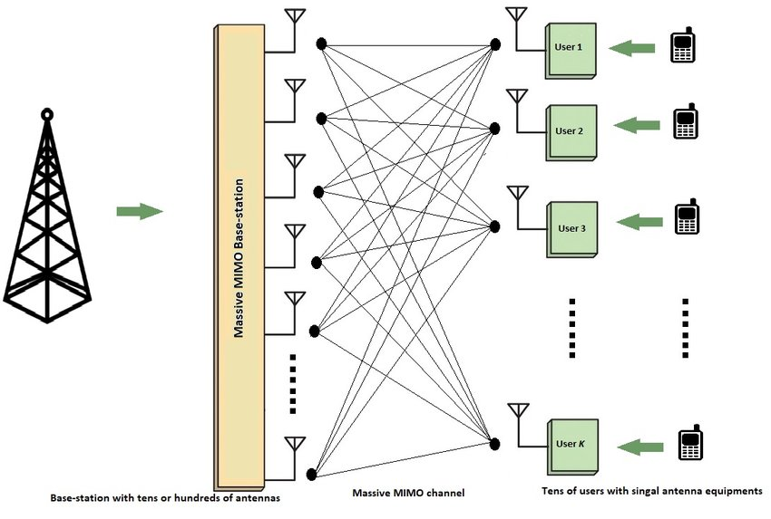Beamforming is an RF management method that maximizes the sign energy on the receiver via way of means of focusing broadcast records to unique users as opposed to a massive area. With 5G, three-dimensional (3D) beam form bureaucracy and directs vertical and horizontal beams on the user.

**Fig 1. Basic structure of a MIMO System**

* **MIMO's primary advantages**

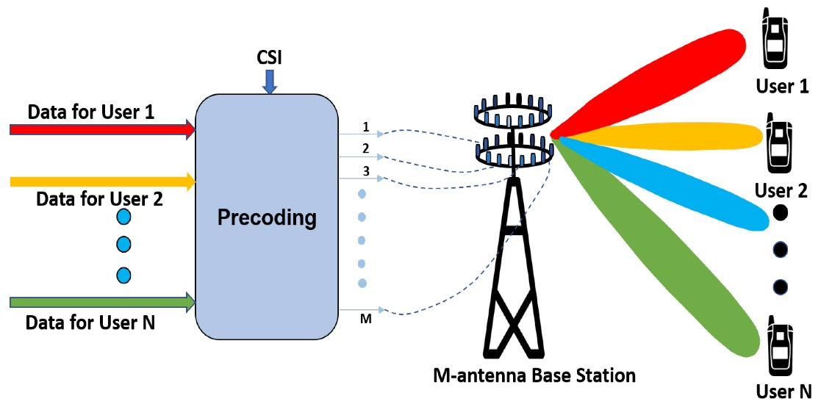MIMO permits stronger signals. It bounces and reflects signals so a user device does not want to be in a clear line of sight. Video and other big-scale content can travel over a network in big quantities. This content travels extra speedily due to the fact MIMO supports more throughput. Many data streams enhance visual and auditory quality. They additionally lower the risk of lost data packets. Multiple-in Multiple-out takes gain of spatial multiplexing to increase wi-fi bandwidth and range. Multiple Input Multiple Output algorithms send information out over or greater antennas and the information is acquired via multiple antennas as well. Multiple Input Multiple Output structures offer a specific ability benefit over traditional single antenna RF systems, together with greater reliable communication.

**Fig 2. MIMO in 5G NR System**

**Objectives: -**

To design an antenna with the following features

* The antenna must be **compact** in size.
* There must be **high isolation** between antenna elements (-10 dB or above).
* There must be **High Diversity Gain.**
* We must achieve **Pattern Diversity**.
* We must achieve **Circular Polarization**, **Polarization Diversity.**
* We must achieve **Wide band.**

**Applications: -**

Our designed antenna can be used in the following

* **MIMO in LAN**

MIMO in wireless LAN. One of the not unusual places makes use of MIMO era these days is Wi-Fi LAN. Wireless routers with multiples antenna come to be common nowadays. Data price may be doubled or accelerated oftentimes with powerful use of MIMO era in Wi-Fi routers and cellular gadgets. In order to have an efficient system, each transmitting and receiving gadgets should be compatible.

* **MIMO in LTE**

MIMO generation may be utilized in LTE and LTE superior radio networks for enhancing community efficiency. With the advent of MIMO generation, signal disturbances because of multipath were extensively reduced. MIMO generation employ multipath phenomenon to maximize transmission via way of means of receiving bounced signals from obstructions.

* **5G and Internet of Things**

5G and Internet of Things requires huge records rate. MIMO technology with Beam forming is one of the huge transmission terminologies for top notch charged 5G networks and IoT. Transmission tower may be ready with multiple antennas. It will find a specific consumer at a particular place and could transmit to that consumer the use of multiple antennas simultaneously. Change in person place may be tracked and person might be treated with the aid of using the antennas positioned on the particular path of person. It permits community operators to gives an uninterrupted provider effectively.

**Background of the Project**

In the past few decades, wireless communication systems have developed due to the growth in mobile phone users and video traffic. Due to this exponential growth in demand, MIMO antennas have become a critical component of modern wireless communication for the capability of providing large channel capacities. Despite the fact that this technology has already been applied in 4G standards, it will play a vital role in 5G standards, since the installation of a large number of elements will lead to inevitable mutual coupling. There are a number of ways in which this could degrade the system's performance:

* Generation of Side-lobes
* Degradation of the Signal to Noise Ratio for receiving the data by other elements rather than radiating into free space
* Degradation of the data throughput by enhancing the value of correlation between the elements
* Degradation of the gain and radiating efficiency of the antenna array

The achievement of a high gain in modern wireless systems requires the reduction of mutual coupling and a reduction of mutual coupling levels, so those issues have drawn the attention of both industry and academia. Researchers have proposed different methods for decoupling, some of which are listed below:

**A Compact Frequency-Reconfigurable Multiband LTE MIMO Antenna for Laptop Applications [1]**

* Dimension of 5mm x 125mm x 1 mm.
* Measured isolation greater than 21 dB.
* Efficiency is greater than 51%, for all operating frequency bands.
* The envelope correlation coefficient is less than 0.0161.

**Planar Antenna in LTCC Technology for the Ultra-Wideband Applications.[2]**

* Dimension of 50 mm x 25 mm x 1.2 mm.
* The bandwidth is 6.2 GHz to 9.7 GHz.
* The correlation coefficient is calculated to be 94.56%.

**Small Printed Ultra-Wideband Antenna with Reduced Ground Plane Effect [3]**

* Dimension of 25 mm x 25 mm x 1.5 mm.
* Operating bandwidth is 2.9 GHz to 11.6 GHz.
* The total antenna efficiency is 79% to 95%.

**Frequency Reconfigurable Microstrip Loop Antenna Covering LTE Bands with MIMO Implementation and Wideband Microstrip Slot Antenna all for Portable Wireless DTV Media Player [4]**

* Dimension of 150mm x 150mm x 0.6 mm.
* The envelope correlation coefficient is equal to 0.5.
* The total antenna efficiency is about 55–83% in the lower band and from 75–92% in the higher band.

**Two-Port MIMO Wide-Band Antenna with Two-Port MIMO Reconfigurable Antenna for Cognitive Radio Platforms [5]**

* Dimension of 80 mm x 80 mm x 1.6 mm.
* Wide-band antennas act like sensing antennas in the frequency range 2.35-5.9 GHz and reconfigurable antennas having tuning range from 2.6-3.6 GHz act like communicating antennas for spectrum interweave CR.
* The annular slot-based planar designs provide a smooth variation of resonance frequency.
* The envelope correlation coefficient is less than 0.01.

**Two element MIMO antenna with frequency reconfigurable characteristics utilizing RF MEMS for 5G applications [5]**

* Dimension of 98 mm x 32 mm x 1mm.
* Reconfigurable antenna that can be switched among 600 MHz, 1.8, 2.4, 3.5, and 5.5 GHz bands.
* Measured isolation greater than 15 dB.
* The Diversity gain in the operating bands is greater than 9.8 dB.
* The Envelop correlation coefficient is less than 0.04.

**Design of a Dual-band MIMO Antenna for 5G Smartphone Application [6]**

* Dimension of 130mm x 74mm x 0.8mm.
* Reflection coefficient is less than -6 dB, and the isolation is better than 12 dB over the band frequency of 3300-3600 MHz and 4800-5000 MHz
* The back L-shaped branches and the front bend line contribute to high frequency impedance matching.
* The envelope correlation coefficient is less than 0.1.

**Pattern-Reconfigurable MIMO Antenna for High Isolation and Low Correlation [8]**

* Dimension of 120 mm x 70 mm x 1.6 mm.
* Measured isolation greater than 21 dB.
* The half-power beamwidths (HPBWs) of the S0, S1, and S2 states are 80, 75, and 95, respectively.
* The impedance bandwidth of the antenna, the efficiencies cited above are satisfied over 70%.
* The envelope correlation coefficient is less than 0.1.

**Four Elements Reconfigurable MIMO Antenna for Dual Band Applications [9]**

* Dimension of 60mm x 80mm x 1.6mm.
* The envelope correlation coefficient is less than 0.5
* Measured isolation greater than 28 dB.
* Peak gain 5.2dB.

After completion of the literature survey, we set our targets

* To make an eight-port MIMO antenna which will greatly increase the throughput i.e., data rate of the antenna.
* To use a cost-effective substrate with good dielectric constant and minimum Loss tangent
* To get impedance bandwidth satisfying for super wideband applications.
* To make the antenna compact, to fit with RF front ends.
* To make a MIMO antenna with better isolation characteristics and diversity performances

**Details of the Project**

**Description: -**

#### In this work, a reconfigurable 8 x 8 multiple-input–multiple-output (MIMO) antenna has been presented for enhancing the performance of 5G applications by employing a compact, reconfigurable antenna. This antenna comprises of microstrip line fed half circular shaped patches supported by a modified connected partial ground plane.. To satisfy the bandwidth requirement for super-wideband (SWB) applications, a rectangular slot is introduced in the partial ground plane. Antenna elements are positioned with rotational asymmetry on opposite sides of the substrate to achieve high port isolation. The ground planes are cut through and an asymmetric feed position is utilized in order to achieve circular polarization on over all the grounds. As a result, the proposed antenna, provides good impedance matching in the range of 2-20 GHz. To introduce the switchable characteristics, a T-shaped stub is connected with the partial ground plane using a photoconductive switch made of cadmium sulphide (CDS) based semiconductor. The operating characteristics of the antenna have been changed when the switch is illuminated by the light-emitting diode (LED). Under the switch-off condition, Reconfigurable of 8-16 GHz fractional bandwidth and a bandwidth ratio of 1:2 is achieved. While for the switched-on condition, the connection between the stub and ground plane is established, which provides a wideband with operating bandwidth from 2-20 GHz. Excellent pattern diversity performance is achieved in the frequency range usable for 5G applications. The proposed structure also shows good diversity performance, and this is verified by the study of envelope correlation coefficient (ECC) The antenna elements are placed in such a formation to obtain better isolation. The antenna has a compact size of 55mm x 55mm

**Software Used: -**

**HFSS**

Ansys HFSS is a 3D electromagnetic simulation software program layout for designing and simulating high- frequency electronics devices which include antennas, antenna arrays, RF or microwave components, excessive pace interconnects, filters, connectors, IC programs and revealed circuit boards. Engineers use Ansys HFSS software program to layout high- frequency, high frequency electronics determined in communication systems, and internet-of-things (IOT) devices. HFSS is an excessive-overall performance full-wave electromagnetic (EM) subject simulator for arbitrary 3D volumetric passive tool modeling that takes gain of the acquainted Microsoft Windows graphical person interface. It integrates simulation, visualization, strong modeling, and automation in easy-to-research surroundings in which answers on your 3D EM troubles are speedy and appropriately obtained. Ansys HFSS employs the Finite Element Method (FEM), adaptive meshing, and notable illustrations to offer you unheard of overall performance and perception to all your 3D EM troubles. Ansys HFSS may be used to calculate parameters which include S Parameters, Resonant Frequency, and Fields. HFSS is an interactive simulation machine whose fundamental mesh detail is a tetrahedron. This permits you to resolve any arbitrary 3-d geometry, specifically people with complicated curves and shapes, in a fragment of the time it might take the use of different techniques. The call HFSS stands for High Frequency Structure Simulator. Ansys use the Finite Element Method (FEM) for EM simulation with the help of using developing/enforcing technology which include tangential vector finite elements, adaptive meshing, and Adaptive Lanczos - Pade Sweep (ALPS). Today, HFSS maintains to steer the enterprise with improvements which include Modes-to-Nodes and Full Wave Spice™. Ansys HFSS has developed over a duration of years with enter from many customers and industries. In enterprise, Ansys HFSS is the device of desire for excessive-productiveness research, development, and digital prototyping.

###### Tutorial hfss - Docsity

###### **Fig 3. Ansys Logo**

**ORIGIN**

Origin is mainly a GUI software program with a spreadsheet the front end. Unlike famous spreadsheets like Excel, Origin's worksheet is column oriented. Each column has related attributes like name, gadgets and different consumer definable labels. Instead of mobiliary method, Origin makes use of column method for calculations. Recent variations of Origin have brought and elevated on batch capabilities, with the purpose of getting rid of the want to application many ordinary operations. Instead, the consumer is based on customizable graph templates, evaluation conversation field Themes which store a selected suite of operations, car recalculation on modifications to statistics or evaluation parameters, and Analysis Templates™ which store a set of operations in the workbook.



**Fig 4. Origin Logo**

**ADOBE ILLUSTRATOR**

Adobe Illustrator is the industry-leading graphic design tool that lets you design anything you can imagine - from logos and icons to graphics and illustrations - and customize it with professional-level precision, as well as time-saving features like [Repeat for Patterns](https://helpx.adobe.com/in/illustrator/using/repeat-patterns-desktop.html) or [Global Edits.](https://helpx.adobe.com/in/illustrator/using/global-edit.html) You can use the graphics you create with Illustrator in any size digital or print format and be confident they’ll look exactly the way you designed them.

An illustrator is an [artist](https://en.wikipedia.org/wiki/Artist) who specializes in enhancing [writing](https://en.wikipedia.org/wiki/Writing) or elucidating concepts by providing a visual representation that corresponds to the content of the associated text or idea. The [illustration](https://en.wikipedia.org/wiki/Illustration) may be intended to clarify complicated concepts or objects that are difficult to describe textually, which is the reason illustrations are often found in children's books.

Illustration is the art of making images that work with something and add to it without needing direct attention and without distracting from what they illustrate. The other thing is the focus of the attention, and the illustration's role is to add personality and character without competing with that other thing.

#### Illustrations have been used in [advertisements](https://en.wikipedia.org/wiki/Advertisement), [architectural rendering](https://en.wikipedia.org/wiki/Architectural_rendering), [greeting cards](https://en.wikipedia.org/wiki/Greeting_card), [posters](https://en.wikipedia.org/wiki/Poster), [books](https://en.wikipedia.org/wiki/Book), [graphic novels](https://en.wikipedia.org/wiki/Graphic_novel), [storyboards](https://en.wikipedia.org/wiki/Storyboards), [business](https://en.wikipedia.org/wiki/Business), [technical communications](https://en.wikipedia.org/wiki/Technical_communication), [magazines](https://en.wikipedia.org/wiki/Magazine), [shirts](https://en.wikipedia.org/wiki/Shirts), [video games](https://en.wikipedia.org/wiki/Video_game), [tutorials](https://en.wikipedia.org/wiki/Tutorial), and [newspapers](https://en.wikipedia.org/wiki/Newspapers). A [cartoon illustration](https://en.wikipedia.org/wiki/Cartoon) can add humor to stories or essays.



**Fig 5. Illustrator Logo**

# Result and Analysis

###### **RECONFIGARABLE UNIT ANTENNA ELEMENT DESIGN**

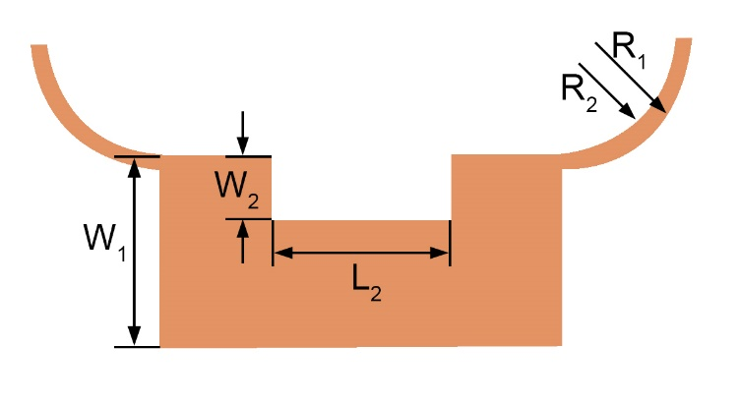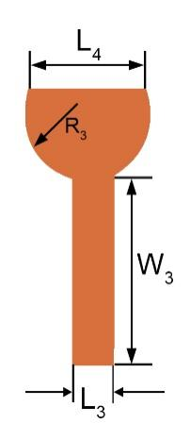The geometry of the antenna element of the reconfigurable MIMO antenna system is shown in Fig.6. This antenna has 8 elements and the dimension is 55mm x 55 mm. The ground plane of the Antenna is excited by the microstrip feed line. A rectangular aperture is clipped from the partial ground plane to achieve the required bandwidth. Eight Antenna elements are presented on the substrate with rotational symmetry. The substrate is 1.6 mm FR4 material. The metallic layers, including the radiation patch and the ground pattern, are made up of 0.035 mm thick copper film.

**(a)**  **(b)**

###### **Fig 6. Geometry of proposed Reconfigurable-MIMO antenna element. (a) Top view and (b) Bottom view**

As shown in Fig. 6, the design process of the proposed Reconfigurable-MIMO antenna element is checked from three types of Reconfigurable antennas, termed Type I, Type II, and Type III respectively. Type III is the proposed Reconfigurable-MIMO antenna element. Type I is the initial antenna, starting with a circular microstrip patch. To improve bandwidth the ground has a rectangular aperture with a height and width of 5mm and 10mm respectively, as shown in Type II. The patch has been clipped from the top to improve the circular polarization and polarization diversity, which forms the Type III (Proposed)

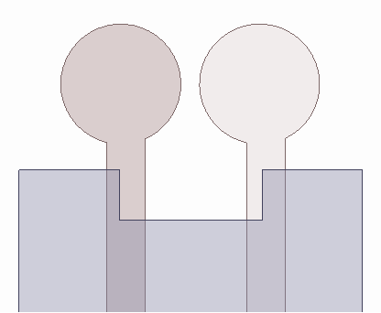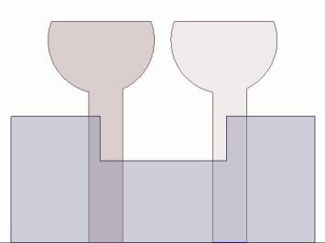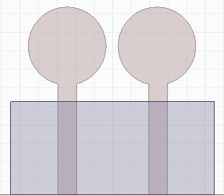

1. (b) (c) (d)

**Fig 7. Evolution of proposed Reconfigurable antennas. (a) Type I, (b) Type II, and (c) Type III, (d)Type IV(Proposed Reconfigurable-MIMO antenna).**

Fig. 8 displays the magnitude of S11 for the three types of reconfigurable antennas represented in Fig. 7. It is found in Fig 7 that the initial circular patch with partial ground plane Type I this antenna performs poorly, which cannot meet the expectation. Then in Type II, Circular patch with rectangular slot loaded partial ground plane to improve the bandwidth and improve the impedance matching. The bandwidth and impedance are improved but the isolation needs to improve to meet the expectation. Hence, all partial grounds are connected, which forms the Type III. The change visualized in Type III to improve the isolation replaces the full circular patch with a half circular patch in addition to previous stapes Type IV (Proposed figure). The proposed figure improves the circular polarization significantly, which we will further check.

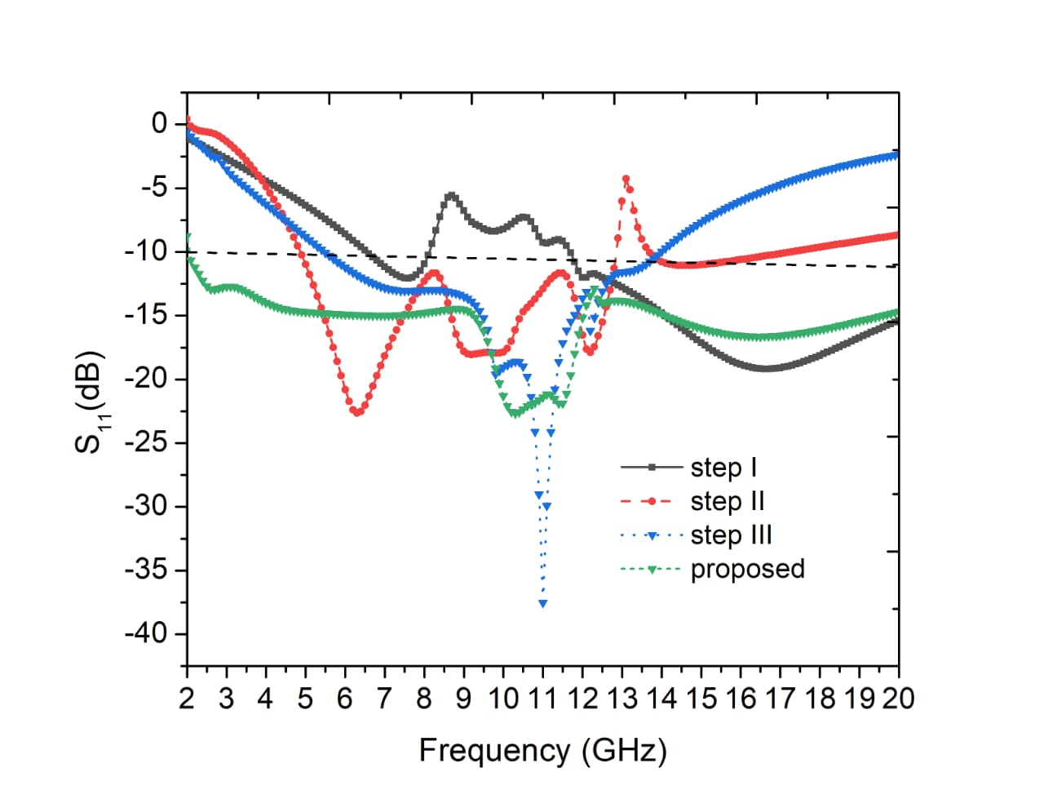

###### **Fig 8. Stepwise improvement of reflection coefficient of the proposed structure**

1. **Reconfigurable MIMO Antenna structure**

#### We have an 8 x 8 MIMO antenna that has been designed using HFSS, with the antenna's dimensions being 55 mm x 55 mm for the design of the MIMO antenna. A total of eight antenna elements are presented on the substrate made of FR-4 material. The antenna elements are arranged symmetrically on the substrate, and the ground plane for the eight antennas is imported. In order to achieve the necessary bandwidth, they have a rectangular shape etched between two antenna elements.

F**ig 9. Proposed Eight-element Reconfigurable - MIMO antenna system.**

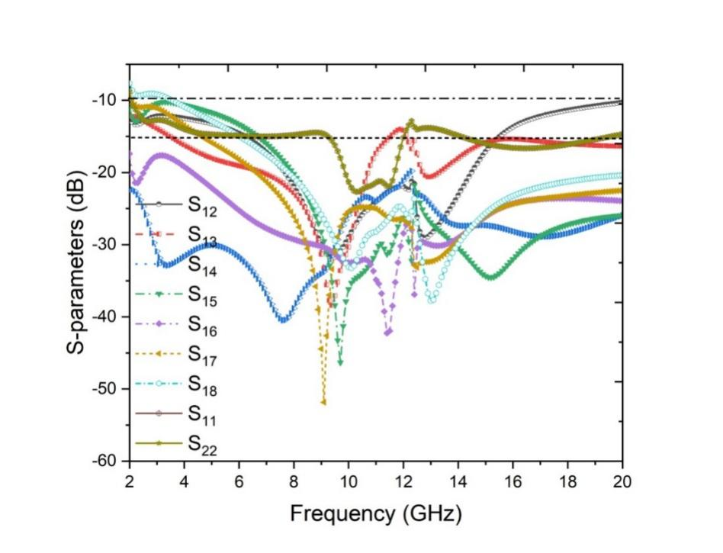**Table 1. Design Parameters (all dimensions are in mm.)**

|  |  |  |  |  |  |
| --- | --- | --- | --- | --- | --- |
| **Para.** | **Value** | **Para.** | **Value** | **Para.** | **Value** |
| L | 55 | W | 55 | R1 | 7.2 |
| L1 | 24 | W1 | 10 | R2 | 6.5 |
| L2 | 10 | W2 | 5 | R3 | 4.2 |
| L3 | 2.7 | W3 | 12.5 |  |  |
| L4 | 10 |  |  |  |  |

**Fig. 10. Result of the 8 x 8 reconfigurable MIMO Antenna**

#### After the compilation of the design through simulation and the analysis of the reflection coefficient and the transmission coefficient of the 8 x 8 MIMO antennas, the result can be seen in Fig. 10

(a) (b)

**Fig. 11. Proposed Antenna after fabrication (a)Top view of the antenna, (b)Bottom view of the antenna**

1. **Output using MIMO antenna’s Reconfigurable property**

#### As we incorporate the reconfigurable part into our design, we can observe the S-parameter at both switch-on and switch-off conditions as we incorporate the reconfigurable part. After we have finished our design using CDS material, we can observe the results of the S parameter and frequency both at switch on and switch off in fig. 11.

**(a) (b)**

**Fig. 12. S parameters of Reconfigurable MIMO antenna system (a) at switch on - off condition and (b) reflection coefficient of all the antennas**

###### **Pattern Diversity in SWB-MIMO Antenna System**

#### In addition to pattern diversity, we have achieved it with our proposed structure. Figure 13 illustrates how polarization diversity is verified using the 3D radiation patterns at 10 GHz for each port

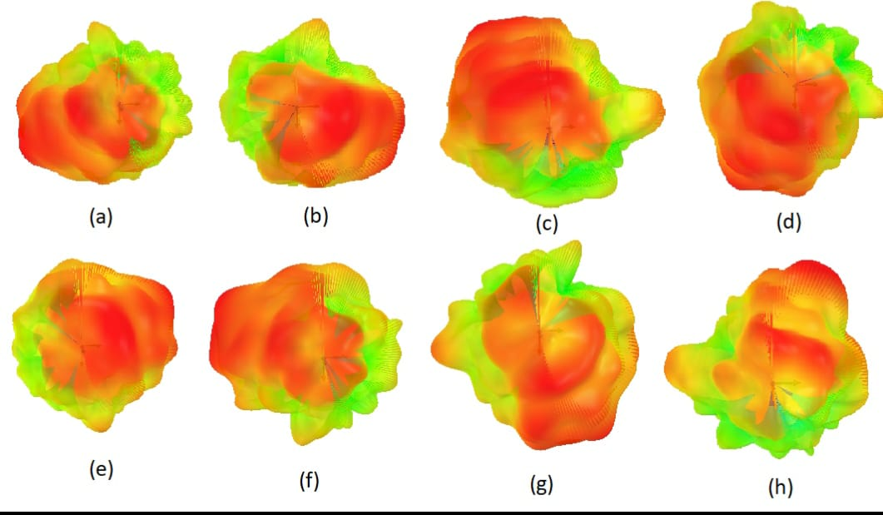**Fig. 13. Pattern diversity performance of Antenna at 10 GHz**

1. 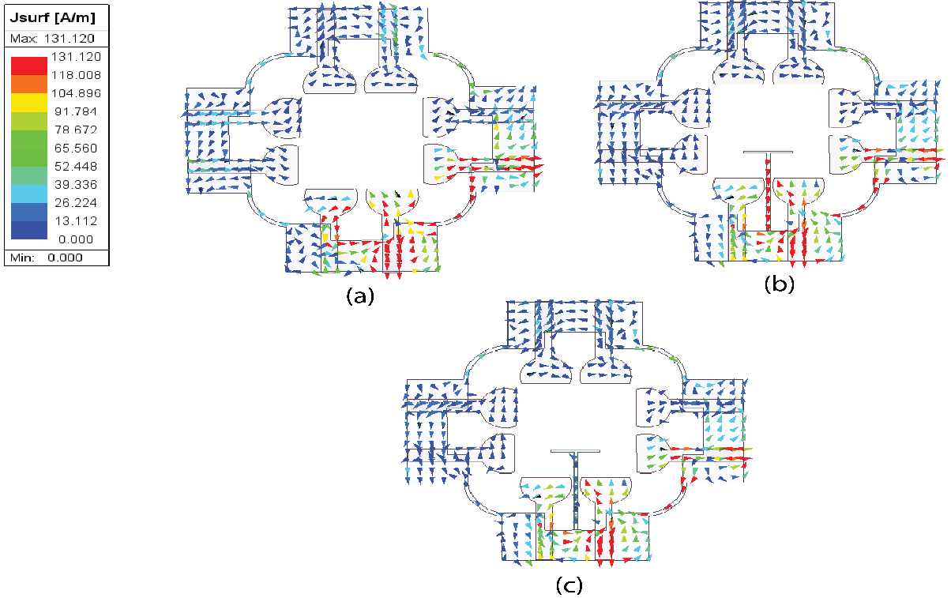**Current Distribution in proposed antenna**

**Fig. 14 Simulated current distribution of Reconfigurable-MIMO antenna system at 10GHz**

This is based on Fig. 13. Fig.13(a), (b), and (c) shows the current distributions between the eight antenna elements, and we can see that with coupling, there is an extremely high current distribution. We can see from Fig.13(b) and (c) that after decoupling, there has been a comparably low current distribution. There is a smaller distribution of current for other antenna elements

1. **MIMO system parameters**

Several important parameters are analyzed to assess the performance of the proposed SWB-MIMO antenna system. The envelope correlation coefficient (ECC) is employed to evaluate the degree of independence between antenna elements, which could be computed by using the S-parameters as follows:

Where ECCij is the ECC between ith and jth antenna elements. It can be seen for our proposed structure that the ECCs are below 0.001 within the frequency band of interest, and meet the communication requirements The diversity gain (DG) is also an important performance indicator of the SWB-MIMO antenna system against channel fading. It can be written as

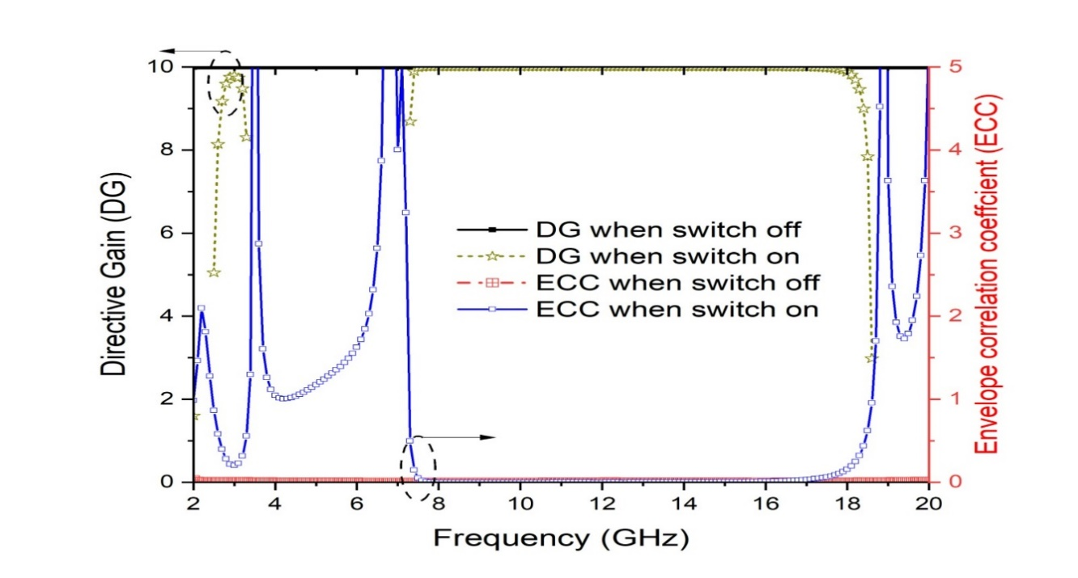Usually, a larger DG value indicates a better MIMO antenna performance. It is observed that the proposed four-element SWB-MIMO antenna system has a larger DG and smaller ECC at the same time.

**Fig. 15 ECC and DG performance of the proposed structure in the operating frequency band at switch on state and switch off state.**

**To prove the effectiveness of the proposed design the proposed work is compared with some previously reported work and shows better performance is highlighted in Table 2.**

**Table 2. Performance comparison of the proposed work with some other reported works.**

|  |  |  |  |  |  |  |
| --- | --- | --- | --- | --- | --- | --- |
|  | **Dimension**  **(mm)** | **No. of antenna Elements** | **Frequency Range** | **Transmission Coefficient** | **ECC** | **Circular polarization** |
| **1.** A Compact Frequency-Reconfigurable Multiband LTE MIMO Antenna for Laptop Applications | 5 x 125 x 1 | 2 | 17/13 Band  704-787MHz  2500-2690MHz | Isolation is more than 21dB | Less  0.0161 | No |
| **2.** Planar Antenna in LTCC Technology for the Ultra-Wideband Applications | 50 x 25 x 1.2 | 1 | 3.57 to 6.53 GHz | Isolation is more than 25dB | NA | No |
| **3.** Small Printed Ultra-Wideband Antenna with Reduced Ground Plane Effect | 25 x 25 x 1.5 | 2 | 2.9 GHz to 11.6 GHz | Isolation is more than 25dB | NA | Yes |
| **4.** Frequency Reconfigurable Microstrip Loop Antenna Covering LTE Bands with MIMO Implementation and Wideband Microstrip Slot Antenna all for Portable Wireless DTV Media Player | 150 x 150 x 0.6 | 3 | LTE bands 3(1.8 GHz) and 7(2.6GHz) | Isolation is 20dB  Or better | 0.5 | No |
| **5.** Two-Port MIMO Wide-Band Antenna with Two-Port MIMO Reconfigurable Antenna for Cognitive Radio Platforms | 80 x 80 x 1.6 | 4 | 694 – 790 MHz  S11 = -20dB | Isolation of 20dB or better | <0.01 | Yes |
| **6.** Two element MIMO antenna with frequency reconfigurable characteristics utilizing RF MEMS for 5G applications | 98 x 32 x 1 | 4 | 600 MHz, 1.8,2.4,3.5,5.5 | Isolation of 15dB  Or better | <0.05 | No |
| **7.** Design of a Dual-band MIMO Antenna for 5G Smartphone Application | 130 x 74 x 0.8 | 4 | 3300 – 3600 MHz  4800 – 5000 MHZ | Isolation of 20dB  Or better | <0.1 | No |
| **8.** Pattern-Reconfigurable MIMO Antenna for High Isolation and Low Correlation | 120 x 70 x 1.6 | 3 | The half-power beamwidths are 80,75,95 | Isolation is less than 21dB | NA | No |
| **9.** Four Elements Reconfigurable MIMO Antenna for Dual Band Applications | 60 x 80 x 1.6 | 4 | Dual band | Isolation is less than 28 dB | <0.1 | No |
| **Our work** | 55 x 55 x 1.6 | 8 | 2-20 GHz | Isolation is less than 30dB | <0.5 | Yes |

**Conclusion**

* Our antenna measures 55mm x 55mm x 1.6mm, which is extremely compact
* Eight identical circular-shaped radiation patches and a partial ground plane make up the proposed antenna.
* The bandwidth range we have is 8-16 GHz, which is considered to be super wide band.
* At the desired frequency, circular polarization, polarization diversity, and pattern diversity are achieved.
* In order to maximize isolation, the antenna slots have been clipped from the top.
* There is a high Diversity Gain and a low ECC for the antenna.
* The antenna we propose can be used in IOT and 5G communications.
* The ECC of the antenna is very low and Diversity Gain is high.
* We are satisfied with the results we obtained.

**Future Scope**

* The size of the antenna can be reduced and can be made compact.
* The isolation is enhanced but it can be optimized further in the future. We will try to use different novel decoupling techniques to optimize the isolation even more.
* The Circular Polarization band can be improved in the future using different novel techniques
* Performance of the antenna can be enhanced with the using of FSS (frequency selective surface) and we will apply it in future.

## References

1. [Byeonggwi Mun](https://ieeexplore.ieee.org/author/37086631324); [Changwon Jung](https://ieeexplore.ieee.org/author/37277023800); [Myun-Joo Park](https://ieeexplore.ieee.org/author/37276966600); [Byungje Lee](https://ieeexplore.ieee.org/author/37281108800), “A Compact Frequency-Reconfigurable Multiband LTE MIMO Antenna for Laptop Applications,” [IEEE Antennas and Wireless Propagation Lett](https://ieeexplore.ieee.org/xpl/RecentIssue.jsp?punumber=7727)., Vol: 13, pp. 1389 – 1392, July. 2014
2. Grzegorz Brzezina, “Planar Antennas in LTCC Technology with Transceiver Integration Capability for Ultra-Wideband Applications,” IEEE Transaction on Microwave Theory and Techniques, Vol: 54, Issue: 6, pp. 2830 – 2839, June 2006
3. [Zhi Ning Chen](https://ieeexplore.ieee.org/author/37421295100); [Terence S. P. See](https://ieeexplore.ieee.org/author/37277334600); [Xianming Qing](https://ieeexplore.ieee.org/author/37280285100), “Small Printed Ultrawideband Antenna With Reduced Ground Plane Effect,” [IEEE Transactions on Antennas and Propagation](https://ieeexplore.ieee.org/xpl/RecentIssue.jsp?punumber=8), Vol:55, Issue:2, pp. 382 – 388, Feb 2007
4. [Zeba Parveen](https://ieeexplore.ieee.org/author/37086519723); [Megha Dadel](https://ieeexplore.ieee.org/author/37860423600) ,“Two-Port MIMO Wide-Band Antenna with Two-Port MIMO Reconfigurable Antenna for Cognitive Radio Platforms,” IEEE Indian Conference on Antennas and Propogation (InCAP),

16 – 19 Dec. 2018

1. [Muhammad Mateen Hassan](https://www.tandfonline.com/author/Hassan%2C+Muhammad+Mateen), [Zeeshan Zahid](https://www.tandfonline.com/author/Zahid%2C+Zeeshan),, [Adnan Ahmed Khan](https://www.tandfonline.com/author/Khan%2C+Adnan+Ahmed), “Two element MIMO antenna with frequency reconfigurable characteristics utilizing RF MEMS for 5G applications,” Vol: 34, Issue: 9,pp. 1210-1224, Mar. 2020
2. [Weijun Zhang](https://ieeexplore.ieee.org/author/37086390221); [Zibin Weng](https://ieeexplore.ieee.org/author/37299991300); [Lei Wang](https://ieeexplore.ieee.org/author/37089611320),“Design of a Dual-band MIMO Antenna for 5G Smartphone Application,” [International Workshop on Antenna Technology (iWAT)](https://ieeexplore.ieee.org/xpl/conhome/8370890/proceeding), 05-07 March 2018
3. [Changyong Rhee](https://ieeexplore.ieee.org/author/37086628090); [Yongjin Kim](https://ieeexplore.ieee.org/author/37280922000); [Taejoon Park](https://ieeexplore.ieee.org/author/38551984000); [Sung-su Kwoun](https://ieeexplore.ieee.org/author/37086632598); [Byeonggwi Mun](https://ieeexplore.ieee.org/author/37086631324); [Changwon Jung](https://ieeexplore.ieee.org/author/37277023800); [Byungje Lee](https://ieeexplore.ieee.org/author/37281108800), “Pattern-Reconfigurable MIMO Antenna for High Isolation and Low Correlation,” [IEEE Antennas and Wireless Propagation Letters](https://ieeexplore.ieee.org/xpl/RecentIssue.jsp?punumber=7727), Vol: 13, pp. 1373 – 1376, July 2014
4. Vipin Choudhary; Manoj Kumar Meshram; Jan Hesselbarth, “Four Elements Reconfigurable MIMO Antenna for Dual Band Applications,” Vol: 7, Issue 1, Feb. 2022|
5. Johnna Powell, “Antenna Design for Ultra-Wideband Radio,” M. A. Sc. Thesis, Massachusetts Institute of Technology, USA, May 2004.